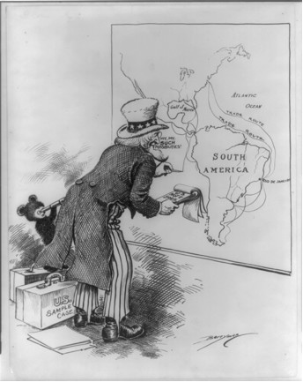#1
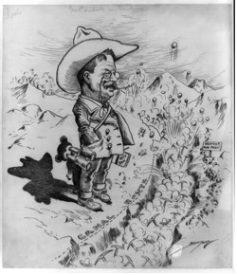#2
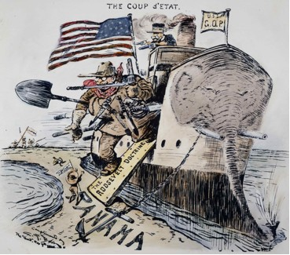#3
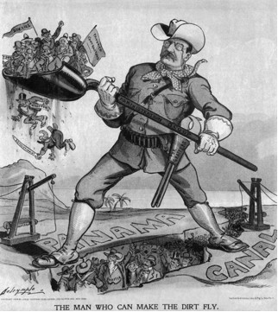#4

Name: ___________________ Date: ____________
Period: ______
Panama Canal Political Cartoons
1. How is Teddy Roosevelt shown to us in each of these cartoons: positively or negatively? For each cartoon, choose and view, and point to specific symbols and details in each image to support your answer.

#1 _________________________________________________________

#2__________________________________________________________

#3__________________________________________________________

#4__________________________________________________________

2. What comment is each cartoonist making about Roosevelt's involvement in the Panama Canal project?
_____________________________________________________________

_____________________________________________________________

3. How is Panama portrayed in cartoon #3? Does this cartoonist appear to support or oppose the "Roosevelt Doctrine", on which Roosevelt is walking on as he leaves the boat? Explain.

_____________________________________________________________

_____________________________________________________________

_____________________________________________________________

_____________________________________________________________

